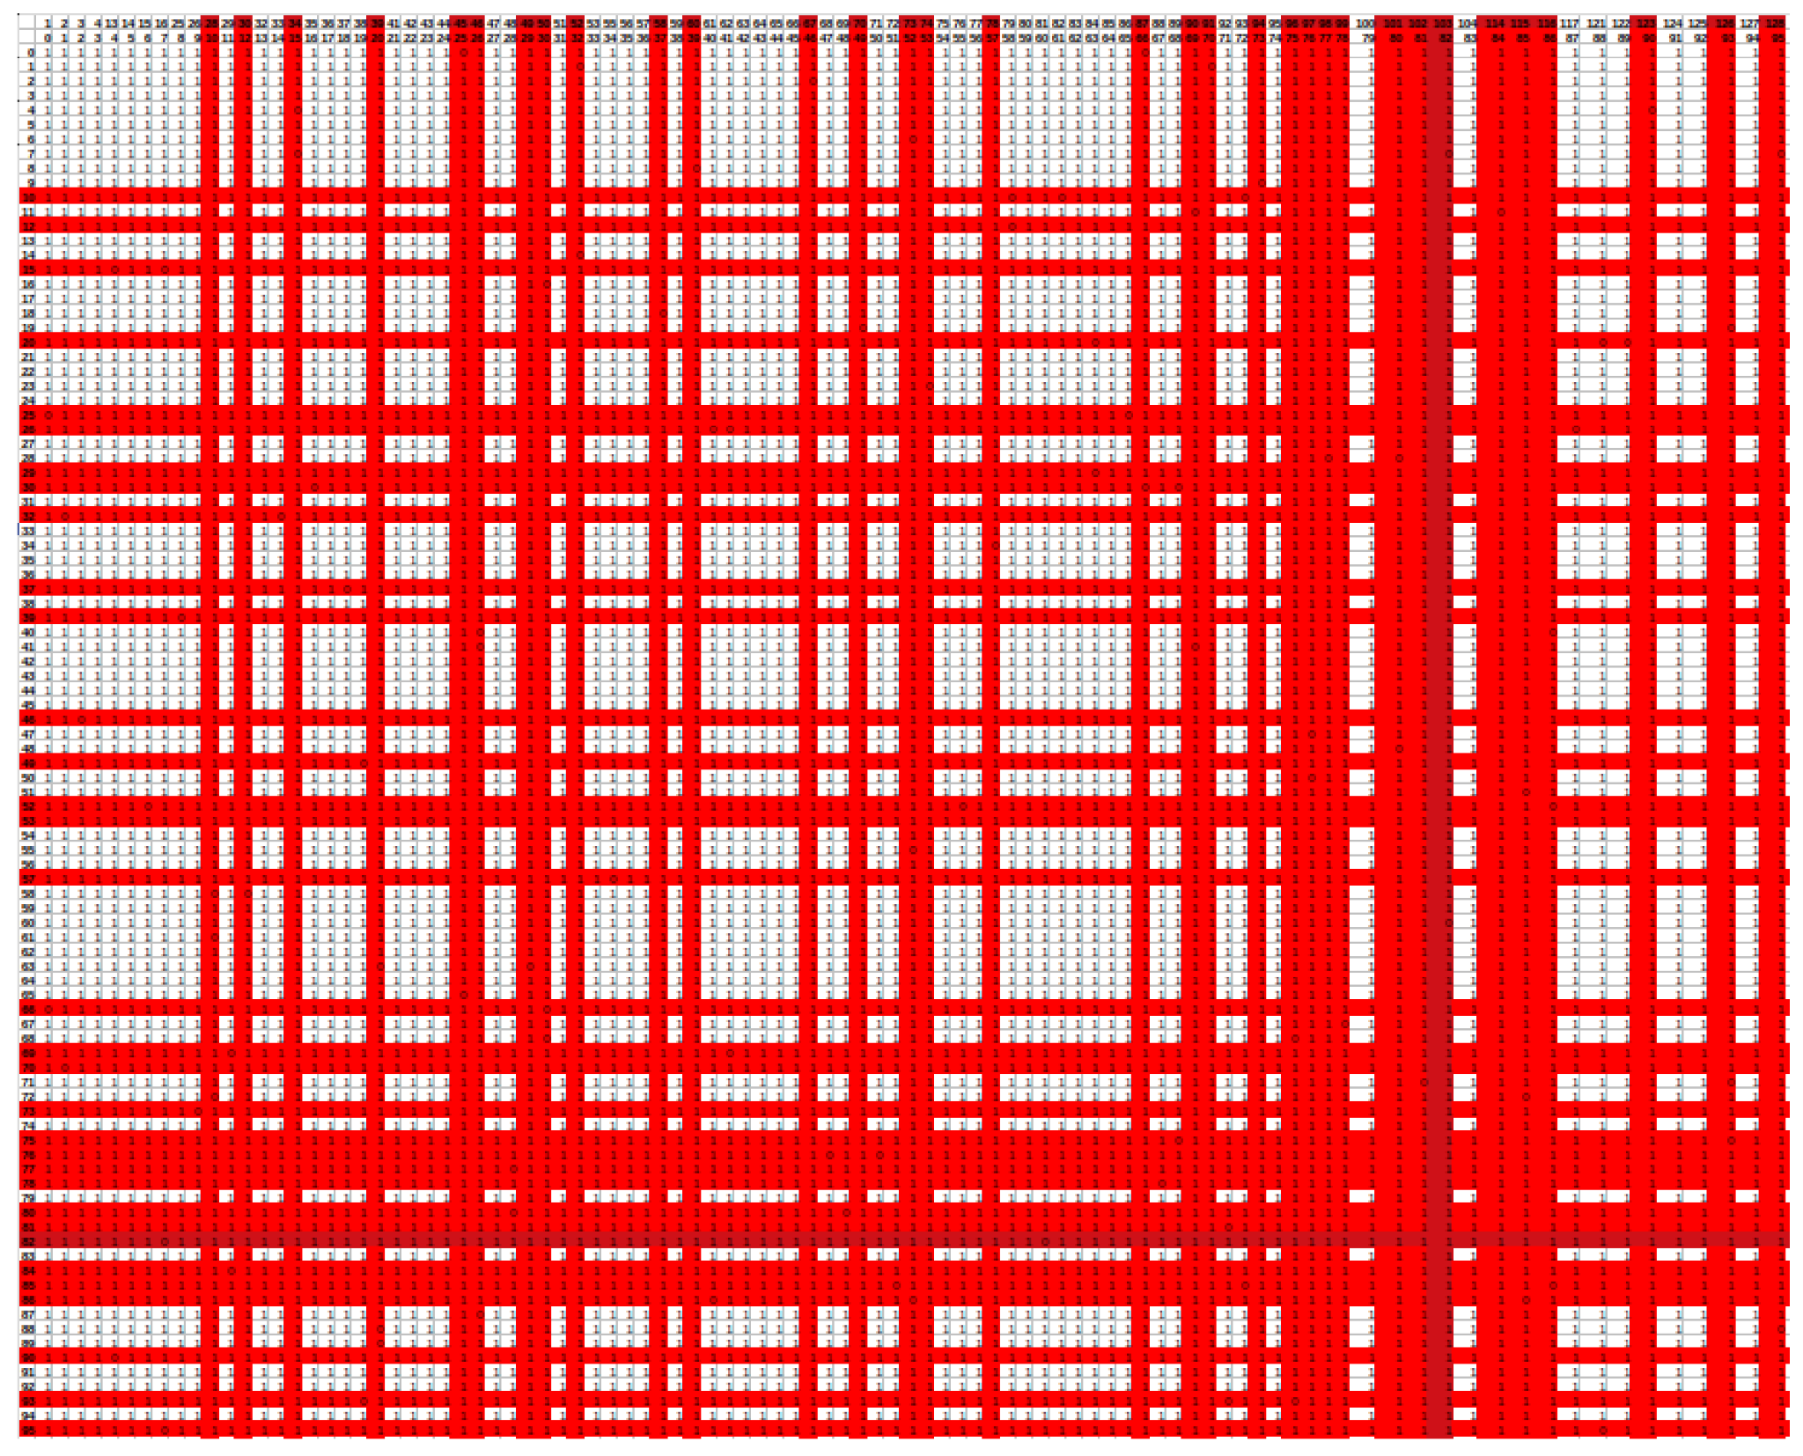

S2 Figure. An adjacency matrix based on the graph of incompatible quads. Incompatible quads are shown as 0 (contain barcodes with less than 4 mismatches), compatible quads as 1(all pairs with mismatches ≥4).